Best wishes by the board of Right to Die Europe
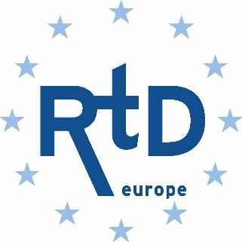
Season Greetings
Merry Christmas
A Prosperous and a Defiant 2022

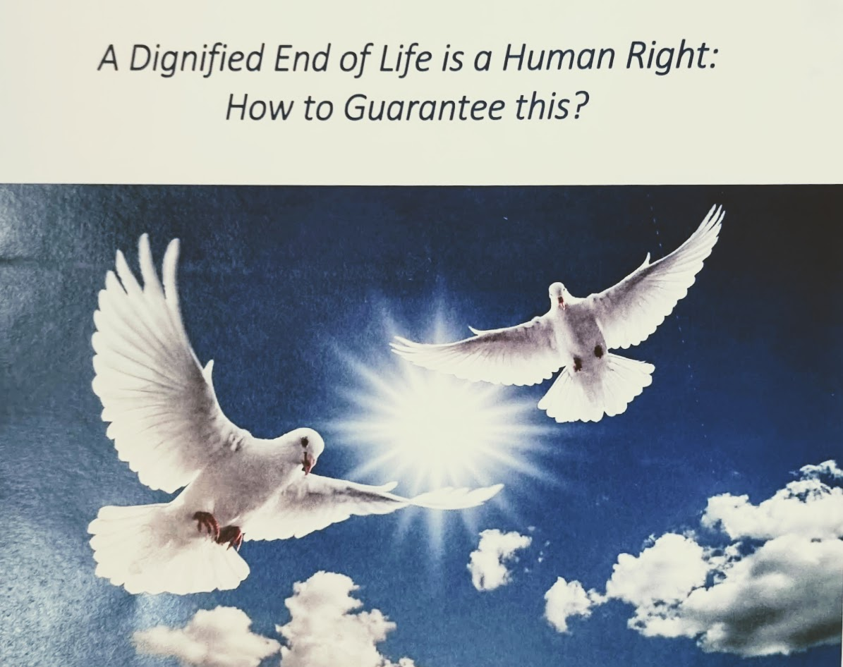

There is some progress in Europe, hopefully in the near future it will become true for all Citizens.

